CYCLEDELIK price list for call outs, labour and priority requests is constantly evolving and changing to remain competitive and offer the best value to our members and clients. Our prices are a fair and honest reflection on the level of service we offer.
We believe in transparency hence full disclosure since we started the business back in April 2007. We also believe that prices (in most cases) should be fixed to allow our customers to budget for their cycle maintenance. For example: Repairs and servicing.
Our call out charges vary depending on the following factors:
- Membership (Best value for money)
- PAGO (Pay as you go. Use as and when and inclusive) Competitively priced
- Time of day (Best times to book for the best value for money may be found on our booking page via our website https://www.cycledelik.com/)
- Mechanics availability (The closer the mechanic is to you, the cheaper the call out is. Free for members)
- Urgent or priority call outs are expensive to PAGO customers as it is resource intensive (reduced to our members). We believe in proactive cycle care to avoid inconvenience and costly urgent call outs. But we also operate a reactive service to make sure our customers journeys incur minimal disruption.
- Bank and public holidays are priced higher than usual.
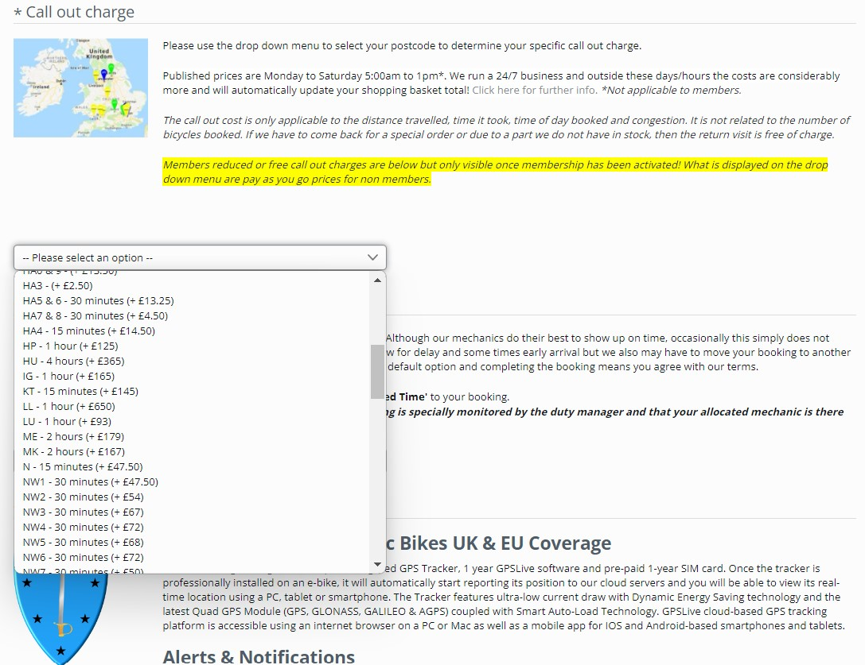

Full PAYGO CYCLEDELIK price list for call outs and labour is accessed via our website by clicking on the BOOK-NOW button:
https://www.cycledelik.com/
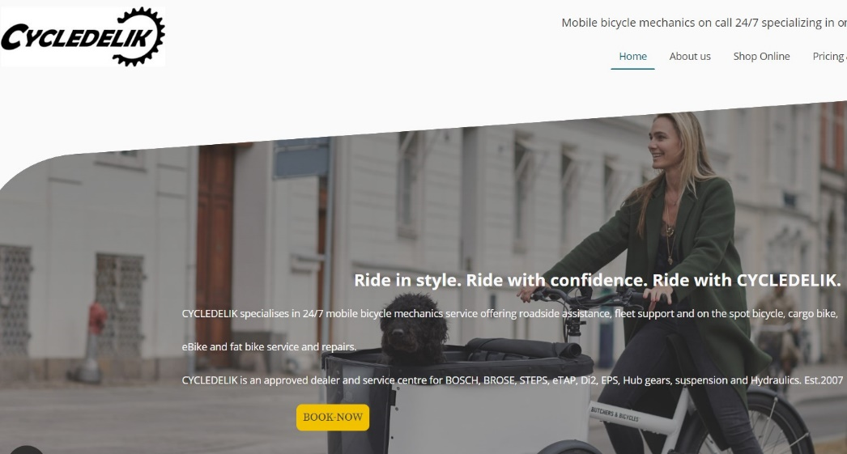
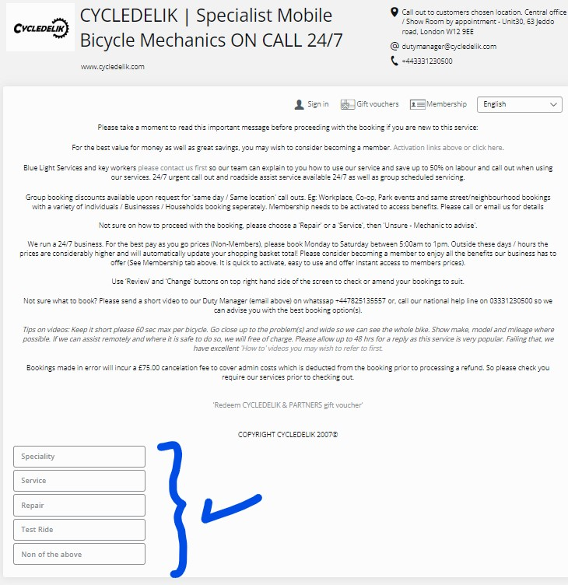
To access membership price list with free puncture repairs and discounts up to 50% on labour, call out charges and priority requests; please sign up for instant access via our booking page.
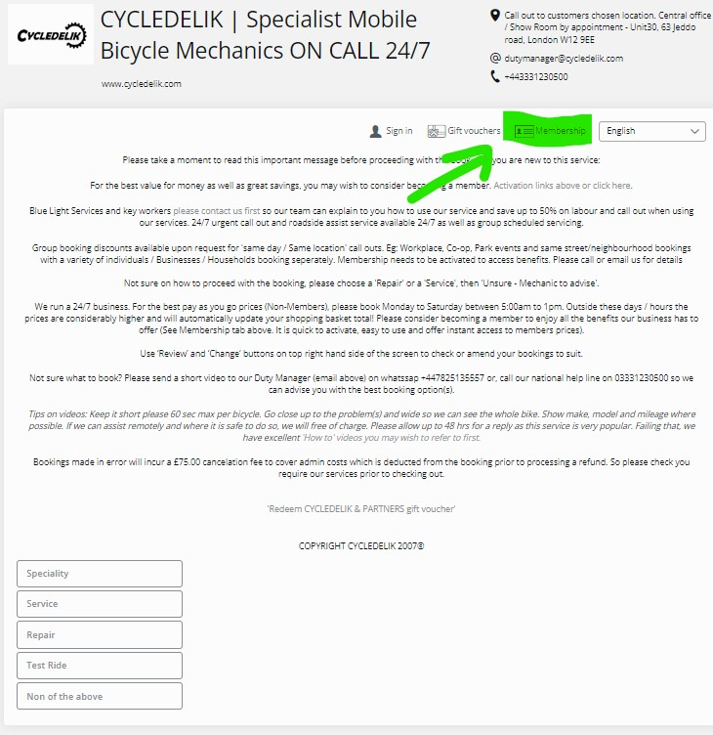

Full CYCLEDELIK cycle, cargobike, eBike, parts and accessories price list may be found at our online store:
https://cycledelik.store/
